How to….. Make an angel from a Paper plate!

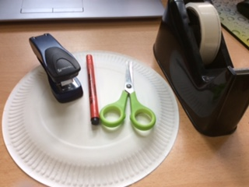
1 – First find a paper plate, or draw around a dinner plate on a piece of paper and cut it out. You will also need a pair of scissors, a pen and either a stapler or Sellotape

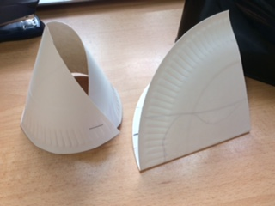
2 – Cut the plate in half and staple the base of the outside edge to create a “Cone”. Fold the other half in half again.

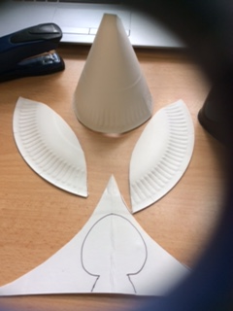
3 – Cut out 2 oval “Wing” shapes – using the edge of the plate as a guide. Then draw a “Head shape” on the remaining section of card

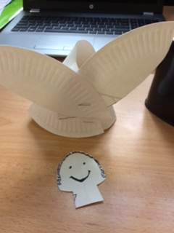
4 – Staple your wings onto the back of the cone body and cut out your head. You can decorate the head with a face and hair etc. Once done, sellotape it inside the cone body!
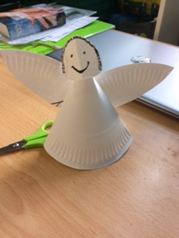

And there it is – A paper plate Angel

