Baby Jesus Manger biscuits
I love making these and they children have no hesitation in eating a baby!
They are as flexible as you want – you can use chocolate or icing, any crushed cereal and anything as a “Baby”!
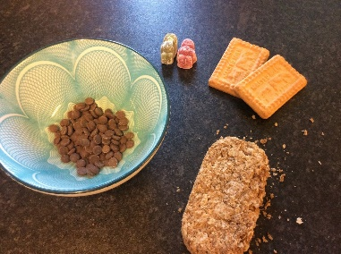
This is what I used – you will only need a small bit of Weetabix and a tablespoonful of chocolate drops!

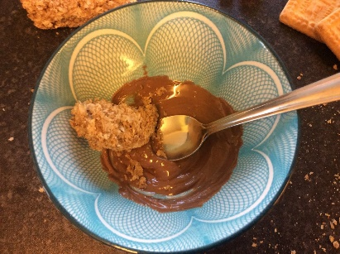
Melt the chocolate – I use a microwave on high for 30 sec, then stir and repeat for 10 sec intervals

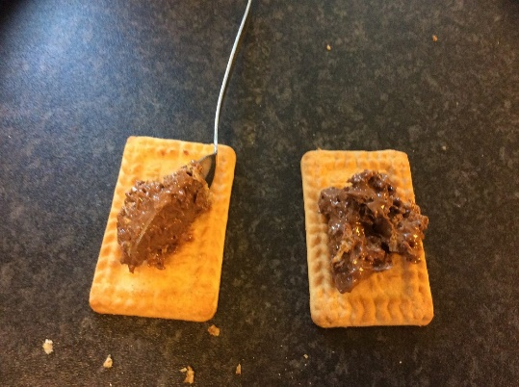

Mix the chocolate and Weetabix and spread on the biscuit

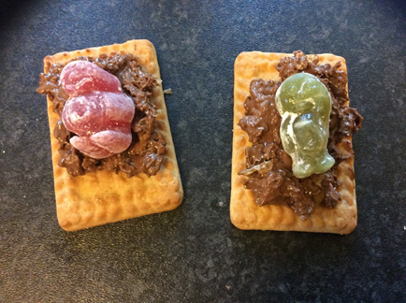
Baby Jesus manger biscuits – but you do have to make more than one!

