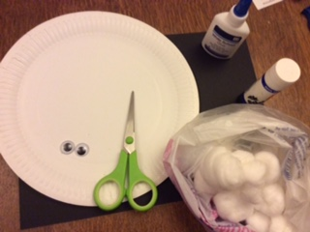
How to make a Baaaaa-rnaby Sheep!
You will need a paper plate – or a round piece of paper
Some black card – you can colour it in black or any colour and have some “Rainbow” sheep!
2 eyes – either googly ones , or just use some white paper
Some glue – PVA is best
Some cotton wool Balls
Some Scissors
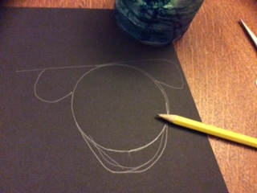
Use a small cup or beaker to draw a circle on the black card.
Then draw some ears on the top and lengthen the face to make it more “Sheep” shaped. Don’t worry about your pencil marks – we will turnover the face so they wont be seen!
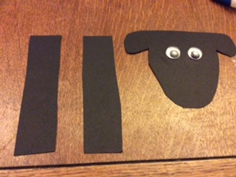

Cut out the shap and 2 long thin strips – about 7-10cm – or as long as you like.
Glue on your eyes – remember to turn your card over so you can’t see the pencil lines.
Put a big dollop of PVA glue on the plate and use a bit of cotton wool to smear it around – then fill the plate with cotton wool balls.
Actually works best if yo open them up a bit and you use less too!
Glue on your face and legs and there you have it!

