Kings Craft!
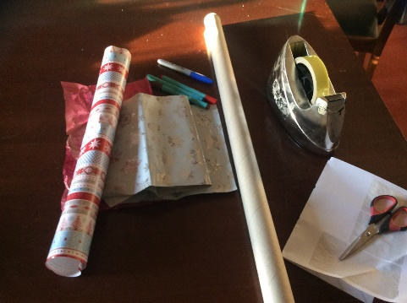
1 – You will need a long cardboard tube, like mine from the middle of wrapping paper, or kitchen rolls, cut into 3 bits – mine are about 15cm long
Wrapping paper
Scissors, Sellotape, stickers and Pens

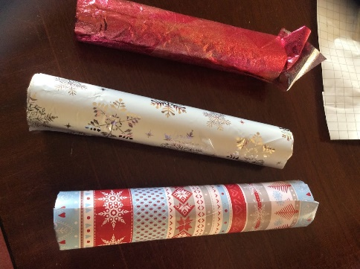
2 – wrap the paper around each tube, tucking it in at the ends and use Sellotape to stop it unrolling.

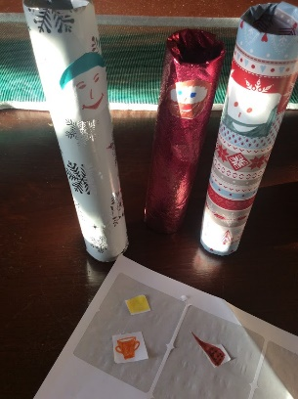
3 – use the stickers to design a face for each King – and make the 3 gifts.
Add them to the kings and check they stand up ok!

Of course you can have as many as you like and dress them up in lots of layers and accessories!
